2014 Junior Golf Program

The PGA Sports Academy is a fun, interactive approach to growing junior participation in golf with PGA Professionals at the forefront of the experience. The objective is to develop core golfers who will continue to play socially or competitively, based on an individual’s desires. The curriculum introduces golf while developing long-term athletic development.

The PGA Sports Academy curriculum includes:
- Sportsmanship, Rules and Etiquette
- Golf Skills
- Fitness and Nutrition
- Golf and “ Near Golf “ Experiences
- Golf and Physical Assessments
- Life Skills

The PGA Sports Academy has three levels:
- Player
- Sport
- Champion

Note: Each Junior Golfer will be evaluated at his or her first clinic and receive a certificate upon completion of a level.

2014 Junior Clinic Schedule and Information

Date: Every Thursday in July and August (Opening Day Thursday June 26, 2014)

Ages: 7-11 (9:00 A.M. to 10:15 A.M.)
12-17 (10:30 A.M. to 11:45 A.M.)

Registration: Students will need to sign up before each clinic at the Practice Range.

Golf Equipment: Golf Clubs will be available upon request.

Cost Per Clinic: $20

Dress Code: Clean shirt tucked into pants or shorts, and golf or athletic shoes. Hats worn
Forward.

2014 Meyer Cup Junior Golf Team Championship: Wednesday, August 20, 2014 (Registration for this event will be all summer leading up to tournament.) Tournament starts@3pm

Contact Information:

Robbie Rush Edgartown Golf Club
PGA Golf Professional 71 Curtis Lane
First Tee Coach of Palm Beach Edgartown, MA 02539
Cell : 561-358-5189 Golf Shop: 508-627-5343
rrush1up@yahoo.com edgartowngolfclub.com

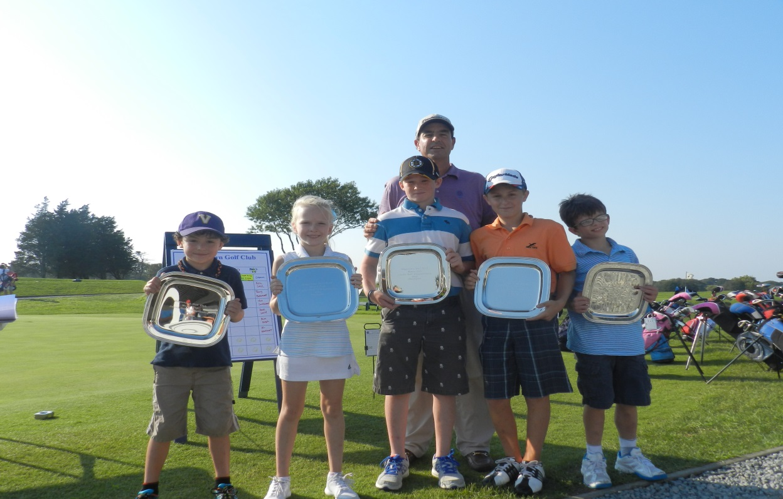

2013 Meyer Cup Junior Team Champions: (L-R) Daniel Serpa, Megan Joel, Jack Murray,
Anthony Jackson and Will Koester.

2012 Champions 2011 Champions

Owen Hess Katie Sack
Jack Albro Max Hammond
Will Koester Michael Habekost
Julia Murray Patrick Glass
Kyle Rollins

Robbie Rush PGA Golf Professional
Edgartown Golf Club
561-358-5189
508-627-5343
rrush1up@yahoo.com

